**Entities**

User

{

_id: ObjectId,

name: String,

email: String,

phone: String,

passwordHash: String, // for secure login

gender: "male" | "female" | "other",

dateOfBirth: Date,

heightCm: Number,

weightKg: Number,

profileImageUrl: String, // optional

preferences: {

preferredWorkoutTime: String, // "06:30"

preferredMealReminders: [String], // ["08:00", "13:00", "20:00"]

moodReminderTime: String // "21:00"

},

Exercise module

exercise: {

defaultPlanId: ObjectId, // from WorkoutPlan

customPlanIds: [ObjectId], // from WorkoutPlan

activeGoalId: ObjectId, // from Goal

streakCount: Number,

lastWorkoutDate: Date,

totalCaloriesBurned: Number,

totalWorkoutTimeMinutes: Number,

badgeIds: [ObjectId] // from Badge

},

Nutrition & Diet module

nutrition: {

defaultMealPlanId: ObjectId, // from MealPlan

customMealPlanIds: [ObjectId], // from MealPlan

waterTargetLiters: Number,

totalWaterDrunkToday: Number,

calorieTargetPerDay: Number,

nutritionStats: {

protein: Number,

carbs: Number,

fats: Number,

fiber: Number,

sugar: Number,

vitamins: [String]

}

},

Mental Health module

mental: {

lastMoodLogged: Date,

weeklyMentalHealthReportId: ObjectId // from MentalHealthReport

},

createdAt: Date,

updatedAt: Date

}

Workoutplan

{

_id: ObjectId,

name: String,

type: "default" | "custom",

userId: ObjectId, // null for default plans

exercises: [ObjectId], // list of Exercise _ids

createdAt: Date

}

Exercise

{

_id: ObjectId,

name: String,

category: String, // e.g., Strength, Cardio

durationType: "time" | "reps",

defaultSets: Number,

defaultReps: Number,

defaultDurationSec: Number, // if time-based

intensity: String, // e.g., "Low", "Medium", "High"

targetMuscles: [String],

videoUrl: String,

instructions: String

}

Badge

{

_id: ObjectId,

name: String, // e.g., "Streak Master", "500 Calorie Burner"

description: String, // e.g., "Awarded for 10-day workout streak"

iconUrl: String, // image/icon for badge

condition: {

type: "streak" | "calories" | "workouts" | "time",

threshold: Number // e.g., 10 for streak, 500 for calories, etc.

},

createdAt: Date

}

ExerciseLog

{

_id: ObjectId,

userId: ObjectId,

exerciseId: ObjectId,

date: Date,

startTime: Date,

endTime: Date,

sets: Number,

reps: Number,

durationSec: Number,

caloriesBurned: Number,

notes: String

}

Goal

{

_id: ObjectId,

userId: ObjectId,

type: "weekly" | "daily",

metric: "workouts" | "calories" | "minutes" | "steps",

targetValue: Number,

currentValue: Number,

startDate: Date,

endDate: Date,

completed: Boolean

}

MealPlan

{

_id: ObjectId,

name: String,

type: "default" | "custom",

userId: ObjectId, // null for default plans

meals: [ObjectId], // list of Meal _ids

createdAt: Date

}

Meal

{

_id: ObjectId,

name: String,

description: String,

foodItems: [ObjectId], // references to FoodItem

loggedTime: Date, // actual meal time

userId: ObjectId,

mealType: "breakfast" | "lunch" | "dinner" | "snack"

}

FoodItem

{

_id: ObjectId,

name: String,

calories: Number,

servingSize: String,

macronutrients: {

protein: Number, // grams

carbs: Number, // grams

fat: Number // grams

},

micronutrients: {

vitaminA: Number,

vitaminC: Number,

iron: Number,

calcium: Number,

// extendable as needed

}

}

WaterLog

{

_id: ObjectId,

userId: ObjectId,

amountML: Number,

time: Date

}

NutritionStats

{

_id: ObjectId,

userId: ObjectId,

date: Date,

totalCalories: Number,

macros: {

protein: Number,

carbs: Number,

fat: Number

},

micros: {

vitaminA: Number,

iron: Number,

calcium: Number,

},

waterConsumedML: Number

}

MoodLog

{

_id: ObjectId,

userId: ObjectId,

mood: "happy" | "sad" | "anxious" | "angry" | "calm" | "stressed" | "neutral",

note: String,

timestamp: Date

}

BreathingExercise

{

_id: ObjectId,

name: String,

description: String,

moodTarget: ["anxious", "stressed", "sad"], // moods this exercise helps with

durationSeconds: Number,

videoUrl: String, // optional

steps: [String], // step-by-step instructions

}

MentalHealthReport

{

_id: ObjectId,

userId: ObjectId,

weekStart: Date,

weekEnd: Date,

moodSummary: {

happy: Number,

sad: Number,

anxious: Number,

stressed: Number,

calm: Number,

angry: Number,

neutral: Number

},

moodTrends: [ // optional - for visualization

{

date: Date,

mood: String

}

],

suggestions: [String]

}

Reminder

{

_id: ObjectId,

userId: ObjectId,

type: "workout" | "meal" | "water" | "mood",

message: String, // e.g., "Time for your workout!" or "Log your mood"

time: String, // "06:30", "13:00", etc.

channel: "sms" | "email",

active: Boolean, // if the reminder is currently enabled

via: [String], // ["sms”]

createdAt: Date,

updatedAt: Date

}

**ER Diagram**  
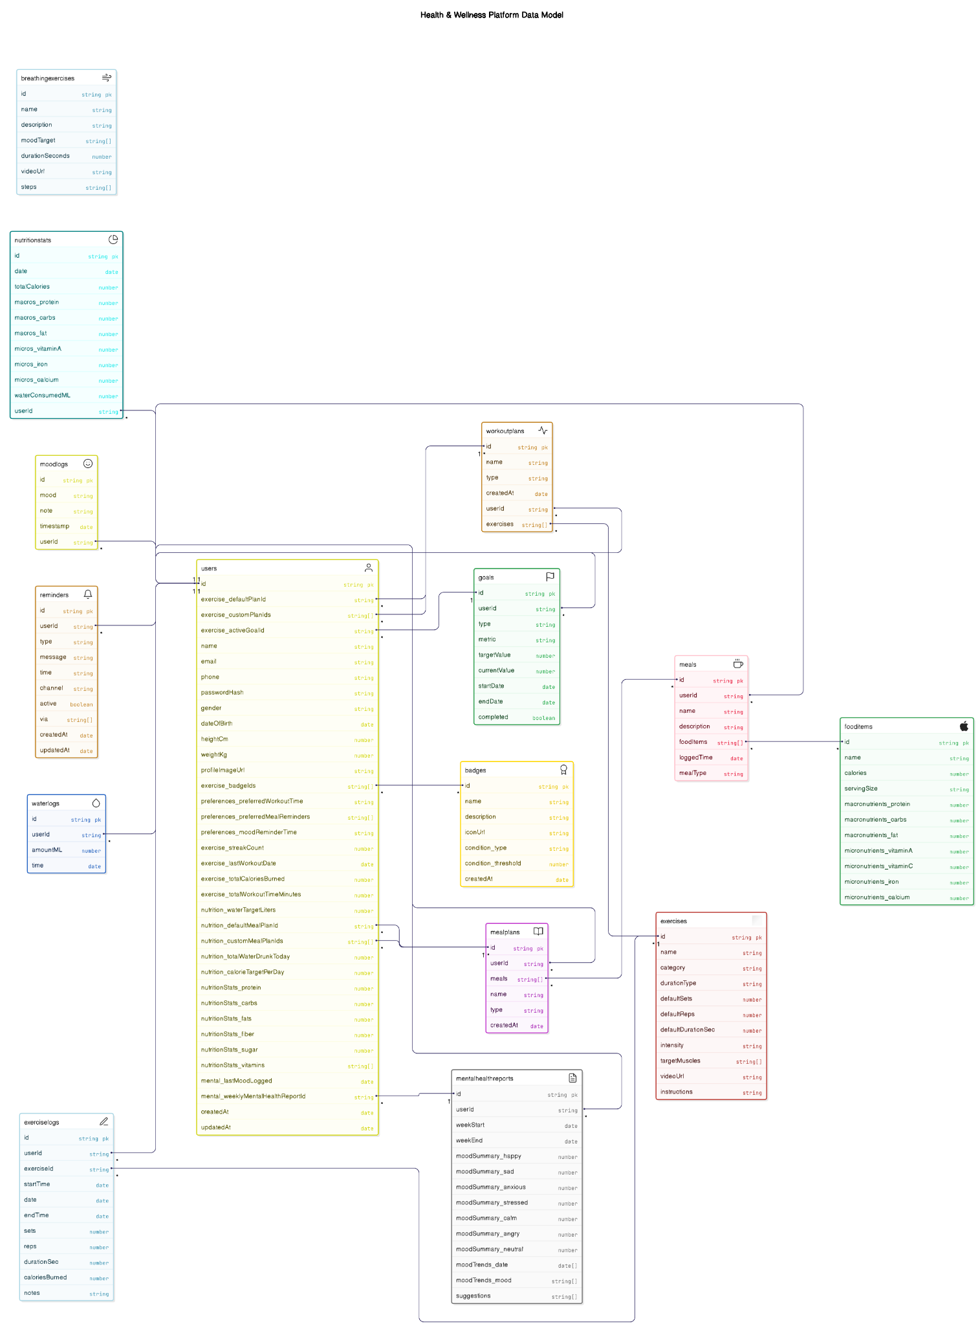

**API Documentation**

User Service

POST /auth/register: Register a new user.

POST /auth/login: Login user and return token.

GET /users/me: Fetch logged-in user profile.

PUT /users/me: Update user profile.

PUT /users/preferences: Update user preferences (workout time, meal reminders, etc).

Exercise Service

-Workout Plan

GET /workout-plans: Get all default + user's custom plans.

POST /workout-plans: Create a custom workout plan.

GET /workout-plans/:id: Get plan details by ID.

PUT /workout-plans/:id: Update a custom workout plan.

DELETE /workout-plans/:id: Delete a custom workout plan.

PUT /users/exercise/select-plan: Select a default/custom plan for the user.

-Exercise

GET /exercises: Get all exercises.

POST /exercises: Add a new exercise (admin only).

GET /exercises/:id: Get exercise details.

-Workout Session Flow

POST /exercise-log/start-session: Start a new workout session.

POST /exercise-log/log: Log an individual exercise (done button).

POST /exercise-log/end-session: Complete session and calculate summary (time, calories, etc.).

GET /exercise-log/today: Get today’s session log.

-Goals

POST /goals: Create a goal (e.g., calories, time, steps).

PUT /goals/:id: Update goal progress.

GET /goals/active: Get active goal for user.

-Streaks & Badges

GET /users/streak: Get current workout streak.

GET /badges: Get all badges user earned.

GET /badges/check: Check for new badges (after workout).

POST /badges/assign: Assign badge to user (automated after session if threshold met).

-Dashboard

GET /dashboard/exercise: Return today’s workout plan, streak, calories burned, time worked out.

GET /exercise-summary: Summary of workout session.

GET /suggestions/workouts:provide suggestion of workout based on the user goals and the stats

Nutrition Service

-Meal Plan

GET /meal-plans: Get all meal plans (default + custom).

POST /meal-plans: Create a custom meal plan.

PUT /meal-plans/:id: Update a custom meal plan.

DELETE /meal-plans/:id: Delete a custom meal plan.

PUT /users/nutrition/select-meal-plan: Select default or custom plan.

GET /suggestions/meals:suggest meals according to stats

-Meals

POST /meals: Log a meal with food items.

GET /meals/today: Get today’s meals.

PUT /meals/:id: Update a logged meal.

DELETE /meals/:id: Delete a logged meal.

-Food Items

GET /food-items: List food items with calories & macros.

POST /food-items: Add a new food item (admin).

-Water Logging

POST /water-log: Log water intake.

GET /water-log/today: Get today’s water logs.

-Nutrition Statistics

GET /nutrition-stats/today: Get today’s stats (calories, macros, micros).

GET /dashboard/nutrition: Dashboard with daily nutrition overview.

Mental Health Service

-Mood Logging

POST /mood-log: Log mood and optional note.

GET /mood-log/today: Get today's mood.

GET /mood-log/weekly-summary: Weekly mood summary for dashboard.

-Breathing Exercises

GET /breathing-exercises?mood=anxious: Get breathing exercises suitable for mood.

-Mental Health Reports

GET /mental-health-report/current-week: Weekly mood breakdown with suggestions.

GET /suggestions/mental:provide mental health tips

Reminder Service

POST /reminders: Create a reminder (meal, workout, mood, water).

GET /reminders: List all reminders.

PUT /reminders/:id: Update a reminder.

DELETE /reminders/:id: Delete a reminder.

**Wireframe**

